Easy Entry / Exit Control Function – CGEA1.3

Functional Description

The Seat Easy Entry Easy Exit function uses Personality CAN messages that are output by the IC as a command to the DSM to change or request the current status of the Easy Entry Easy Exit seat feature. The Instrument Cluster uses the Seat Easy Entry Easy Exit status for the Message Center function to enable or disable the Seat Easy Entry Easy Exit feature in the DSM module.

Starting in MY2019 with U625/U611 the Settings are migrating from the cluster to Center stack. This STSS supports displaying settings in the cluster or configuring the cluster settings off if they are displayed in the Center stack.

Interfaces

Interface Context Diagram (I/O Block Diagram)
Figure 1 Easy Entry / Exit Function Context Diagram

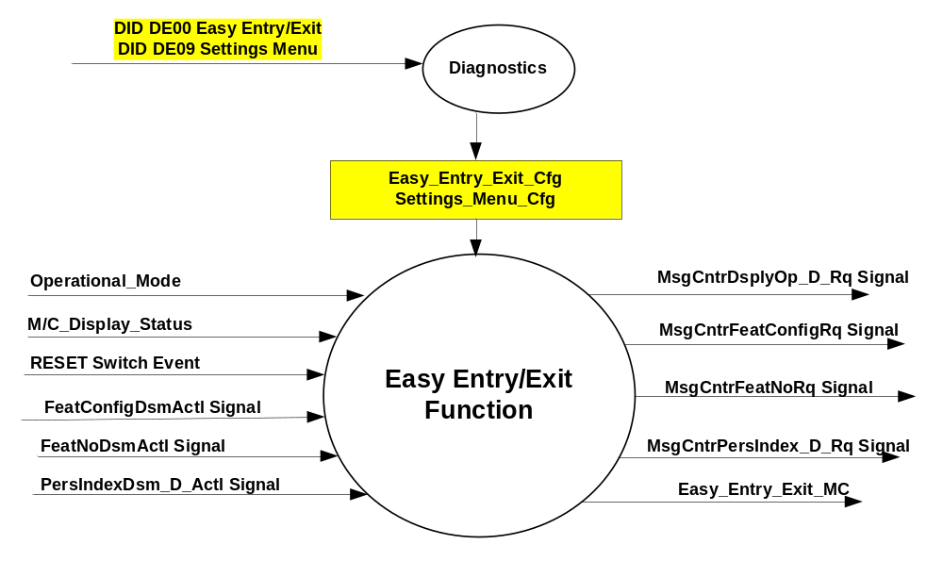

Inputs

- INTERNAL:
- Reset Switch Event
- Easy_Entry_Exit_Cfg
- Settings_Menu_Cfg
- Operational_Mode
- M/C_Display_Status
- MUX message on the CAN Bus from BCM

- FeatConfigDsmActl Signal
Signal Name | Size  (bits) | Detail | Units | Res. | Offset | State  Encoded | Min | Max
FeatConfigDsmActl | 16 | - | Undefined | 1 | 0 |  | 0  (0x0) | 65535  (0xFFFF)

- FeatNoDsmActl Signal
Signal Name | Size (bits) | Detail | Units | Res. | Offset | State Encoded | Min | Max
FeatNoDsmActl | 16 | - | Number | 1 | 0 |  | 0  (0x0) | 65535  (0xFFFF)

- PersIndexDsm_D_Actl Signal
Signal Name | Size  (bits) | Detail | Units | Res. | Offset | State Encoded | Min | Max
PersIndexDsm_D_Actl | 3 |  | SED | 1 | 0 |  | 0  (0x0) | 1  (0x7)
 |  | PERS_1 |  |  |  | 0 (0x0)
 |  | PERS_2 |  |  |  | 1 (0x1)
 |  | PERS_3 |  |  |  | 2 (0x2)
 |  | PERS_4 |  |  |  | 3 (0x3)
 |  | Vehicle |  |  |  | 4 (0x4)
 |  | Unused |  |  |  | 5(0x5)
 |  | Unused |  |  |  | 6 (0x6)
 |  | Unused |  |  |  | 7 (0x7)

Outputs
- Easy_Entry_Exit_MC
- MUX message on the CAN Bus

- MsgCntrDsplyOp_D_Rq Signal
Signal Name | Size (bits) | Detail | Units | Res. | Offset | State Encoded | Min | Max
MsgCntrDsplyOp_D_Rq | 3 |  | SED | 1 | 0 |  | 0  (0x0) | 1  (0x7)
 |  | NULL |  |  |  | 0 (0x0)
 |  | QUERY |  |  |  | 1 (0x1)
 |  | SET |  |  |  | 2 (0x2)
 |  | UPLOAD |  |  |  | 3 (0x3)
 |  | RESTORE |  |  |  | 4 (0x4)
 |  | COPY |  |  |  | 5(0x5)
 |  | Not used |  |  |  | 6 (0x6)
 |  | Not Used |  |  |  | 7 (0x7)
.

- MsgCntrFeatConfigRq Signal
Signal Name | Size  (bits) | Detail | Units | Res. | Offset | State  Encoded | Min | Max
MsgCntrFeatConfigRq | 16 |  | Undefined | 1 | 0 |  | 0  (0x0) | 65535  (0xFFFF)

- MsgCntrFeatNoRq Signal
Signal Name | Size (bits) | Detail | Units | Res. | Offset | State Encoded | Min | Max
MsgCntrFeatNoRq | 16 |  | Number | 1 | 0 |  | 0  (0x0) | 65535  (0xFFFF)

- MsgCntrPersIndex_D_Rq Signal
Signal Name | Size (bits) | Detail | Units | Res. | Offset | State Encoded | Min | Max
MsgCntrPersIndex_D_Rq | 3 |  | SED | 1 | 0 |  | 0  (0x0) | 1  (0x7)
 |  | PERS_1 |  |  |  | 0 (0x0)
 |  | PERS_2 |  |  |  | 1 (0x1)
 |  | PERS_3 |  |  |  | 2 (0x2)
 |  | PERS_4 |  |  |  | 3 (0x3)
 |  | Vehicle |  |  |  | 4 (0x4)
 |  | Not Used |  |  |  | 5(0x5)
 |  | Not Used |  |  |  | 6 (0x6)
 |  | Not Used |  |  |  | 7 (0x7)

Function/Performance

Operational Modes

Mode | Differentiating Vehicle Conditions
Sleep Mode | Easy Entry / Exit Control Function Text Message Disabled
Limiting Mode | Easy Entry / Exit Control Function Text Message Disabled
Normal Mode | Easy Entry / Exit Control Function Text Message Enabled / Disabled
Crank Mode | Easy Entry / Exit Control Function Text Message Enabled / Disabled

Voltage Levels

Refer to the Cluster Features table located in the Operational Modes and Voltage Range Strategies section in this SPSS

Human-Machine Interface

Visual

Indicator Graphics / Display Format
For High End Display (SHMI), refer to “<Program> Cluster Menu Structure.xls” and Program VAPS Model.

For Base display, refer to Message Center Function description reference "BEF Display 2x14 Text Message List.xls" file -- Message ID SU 260

Indicator Color Coordinates

Reference section COLOR & ILLUMINATION REQUIREMENTS (GRAPHICS)

Indicator Characteristics
Refer to Message Center X Display_Y Button Interface Section, where X and Y are appropriate values in this document.

Audio

None

Switch Control Logic

Consumer access to the Easy Entry / Exit Configuration shall be as specified in the message center basic functionality display as specified in Message Center X Display_Y Button Interface Section, where X and Y are appropriate values in this document.

System Accuracy

Within a 150 msec of receiving a message that results in a change of state the cluster will update the display to the proper status.

Operation: Performance and Functional

Subsystem Algorithm Flowchart / State Diagram

Figure 2 Easy Entry/Exit Flowcharts
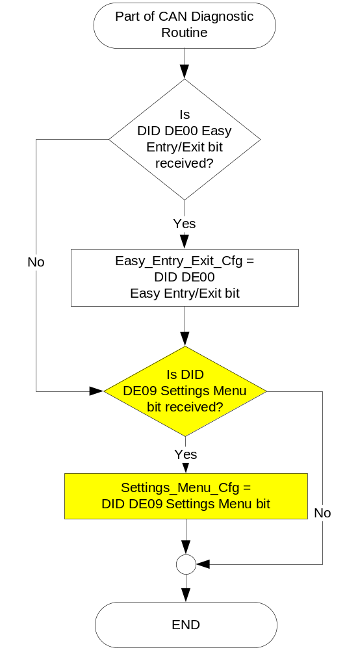

Figure 3: Easy Entry/Exit input Flowcharts

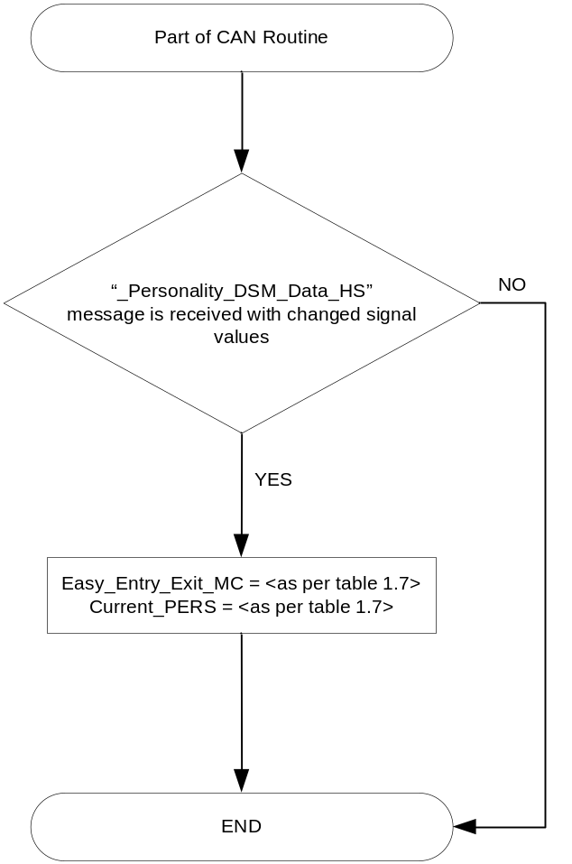

Figure 4: Easy Entry/Exit input SET request Flowcharts

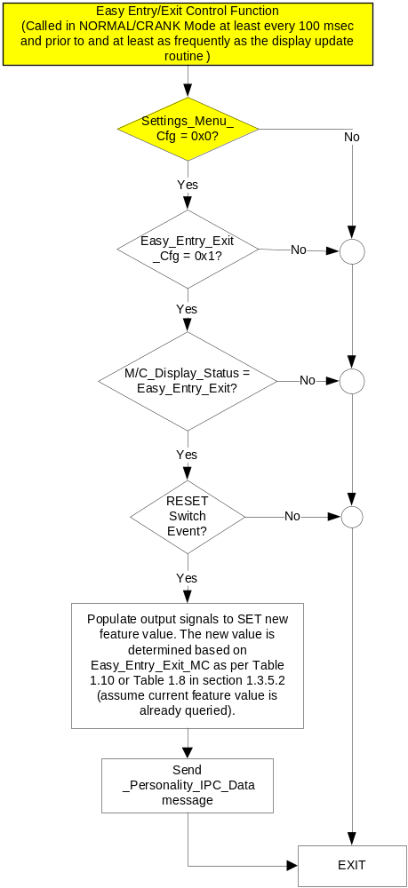

Note: In the Easy Entry/Exit Function Flowchart, the definition of "RESET Switch Event" is defined in Message Center X Display_Y Button Interface Section, where X and Y are appropriate values in this document.

Operation Description (supports algorithm flowchart /state diagram)

- Easy Entry Exit State Assignment
FeatNoDsmActl | FeatConfigDsmActl Signal | PersIndexDsm_D_Actl Signal | Easy_Entry_Exit_MC |  | Current_PERS ⁽³⁾
0x701⁽¹⁾ | 0x0000 (Off) | 0x0 – 0x4 |  | 0x00 | 0x0 – 0x4
0x701⁽¹⁾ | 0x0001 (On) | 0x0 – 0x4 |  | 0x01 | 0x0 – 0x4
0x701⁽¹⁾ | Other ⁽²⁾ |  |  | 0x04 (Error) | Last Known
Missing per Section 1.4.1 ⁽²⁾ |  |  |  | 0x04 (Error) | Last Known
⁽¹⁾ Easy Entry/Exit Feature Number. Reference is Feat Num table in “Vehicle Personalization FS”
⁽²⁾ Message Response is faulted
⁽³⁾ Equal to the received “PersIndex<--->” signal value. When faulted Keep last known value.

- SHMI Display and Easy Entry/Exit Request Messages

based upon Easy_Entry_Exit_MC

Easy_Entry_  Exit_MC | Display Menu | 5-Button Switch Selection Event | MsgCntrDsplyOp_D_Rq  Signal | MsgCntrFeatNoRq  Signal | MsgCntrFeatConfigRq  Signal | MsgCntrPersIndex_D_Rq  Signal
0x00 |  | Up/Down + OK (Select On) | SET (0x2) | 0x701 | 0x0001 | Current_PERS
0x01 |  | Up/Down + OK (Select Off) | SET (0x2) | 0x701 | 0x0000 | Current_PERS
0x4 |  | Up/Down + OK (Select Any) | SET (0x2) | 0x701 | 0x0001 | Current_PERS

- Base Message Center Display and Easy Entry/Exit Request Messages

based upon Easy_Entry_Exit_MC

Easy_Entry_  Exit_MC | MC Display  MSG. ID: SU260 | Reset Switch Event | MsgCntrDsplyOp_D_Rq  Signal | MsgCntrFeatNoRq  Signal | MsgCntrFeatConfigRq  Signal | MsgCntrPersIndex_D_Rq  Signal
0x00 | EASY ENTRY  ON <OFF> | Yes | SET (0x2) | 0x701 | 0x0001 | Current_PERS
0x01 | EASY ENTRY  <ON> OFF | Yes | SET (0x2) | 0x701 | 0x0000 | Current_PERS
0x4 | EASY ENTRY  ON OFF | Yes | SET (0x2) | 0x701 | 0x0001 | Current_PERS

- This feature will be set to ENABLED at the instrument cluster manufacturing plant via diagnostic at Vehicle Operations using DID DE00. Easy_Entry_Exit_Cfg is set equal to the last value received in the diagnostic routine.

Function Safety Classification (EMC)

Class B

Memory Storage

Parameter Name | Description | Value at  Battery Connect | Value at  Wake-up
Easy_Entry_Exit_MC | Output(s) displayed in the M/C | 255 (0xFF) | Do Not Init
Current_PERS | Current Personality Profile | PERS_1 (0x0) | Do Not Init
MsgCntrDsplyOp_D_Rq  Signal | Output Signal to indicate Request Type. | NULL (0x0) | Do Not Init
MsgCntrFeatNoRq  Signal | Output Signal to indicate Feature Number. | (0x0000) | Do Not Init
MsgCntrFeatConfigRq  Signal | Output Signal to Specify the desired feature Value. | (0x0000) | Do Not Init
MsgCntrPersIndex_D_Rq  Signal | Output Signal to indicate which personality profile is being accessed. | PERS_1 (0x0) | Do Not Init
FeatNoDsmActl Signal | Input signal sent from BCM to indicate Feature Number. | (0x0000) | Do Not Init
FeatConfigDsmActl Signal | Input signal sent from BCM to indicate current value of the feature setting for the feature that is being set or queried. | (0x0000) | Do Not Init
PersIndexDsm_D_Actl Signal | Input signal sent from BCM to indicate which personality profile is being reported. | PERS_1 (0x0) | Do Not Init
Easy_Entry_Exit_Cfg | State indicators for feature presence controlled via CAN at EOL at VO plant. Set to disabled at Cluster Supplier Manufacturing Plant | Use Stored Value | Use Stored Value
Settings_Menu_Cfg | Configures cluster to display items in the Settings menu (Set to “cluster” at cluster supplier manufacturer plant) | Use Stored Value | Use Stored Value
M/C_Display_Status | State Indicator to identify which text is currently being displayed on Message Center display. See * | See * | See*
RESET Switch Event | Event that is indicated as per the switch interface for the Message Center. See * | See * | See*
Operational_Mode | 4 state indicator for cluster operational mode | Limited | Limited, Normal or Crank
* Refer to Message Center X Display_Y Button Interface Section, where X and Y are appropriate values in this document.

Reconfigurable Telltale
Not Applicable

Prove Out
Not applicable

Message Center Msg
Refer to Message Center Function description reference "BEF 2x14 Text Message List.xls" -- Message ID SU 260.

Error Handling

Missing Message Strategy

The signals will be declared missing as per the Diagnostics section of this SPSS.

DTCs states and history will be determined as per the Diagnostics section of this SPSS.

If Easy_Entry_Exit_Cfg = Disabled, the cluster shall never log a missing message DTC for this feature.

Configuration Mismatch
N/A

Diagnostics

Self Test

None

Engineering Test Mode

Reference section “Dealer / Engineering Test Mode (ETM)”

Part II Performance
Supported Diagnostic Trouble Codes (DTCs)
DTC | Description
C14000 | Loss of Communication with BCM

DID DExx:
Block  Num | Block Description | Byte(s) | Bits | State: Description | "0" | "1" | Default | Comments/  Information
PACKETED BLOCKS
$00 | Option Content (B&A) | * | * | Easy Entry/Exit | Disabled | Enabled | Enabled | This parameter allows the Easy Entry/Exit settings menu to be displayed in the cluster. It can be over-ridden by the Settings Menu config.
$09 | Option Content (B&A) | * | * | Settings Menu | Cluster | Center Stack | Cluster | This parameter allows the Settings menu to be displayed in the cluster when 0x0. When 0x1, the expectation is that settings are displayed in the Centerstack. For this feature (when 0x1), the cluster will remove almost all items from settings menu. (Cluster display choices remain). Note this is a global config, each feature still has its own config for presence on vehicle.
*Byte and bit location to be identified in Part II Specification for this cluster

Reference Specification

EF-0015 PERSONALIZATION – EASY ENTRY
EF-0099 PERSONALIZATION – EASY ENTRY

Revision History
SPSS Module Revision History

Revision Level | Name | Change Description | Date
1.0 | V. Patel | Updated for CGEA 1.3 based on CGEA STSS v2.0  Section 1.2.2 – Removed table referencing the HS-CAN message that contains the input signal.  Section 1.2.3 – Removed table referencing the HS-CAN message that contains the output signal.  Section 1.2 – Deleted “Position” column from the input and output signal tables.  Section 1.4 – Rewritten. Deleted references of specific missing message flags and timer.  Section 1.5.3 – Deleted DTC logging criteria from the table. | 4/19/2010
2.0 | S. Watkins | Starting in MY2019 with U625/U611 the Settings are migrating from the cluster to Centerstack. This STSS update is to support this effort. A configuration is added to ensure backward compatiblity.  Changes shown in yellow:  - Section 1.1 – Updated description to mention Center Stack  - Section 1.2.1, Figure 1 – Added DE09 Settings Menu  - Section 1.2.2 – Added Settings_Menu_Cfg  - Section 1.3.1 – Added “Enabled” to Crank mode (defect fix unrelated to other changes)  - Section 1.3.5.1, Figure 2 – Added DE09 Settings Menu  - Section 1.3.5.1, Figure 4 – Added decision box for Settings_Menu_Cfg and also added “Crank” to first box (defect fix unrelated to other changes).  - Section 1.3.5.4 – Added Settings_Menu_Cfg  - Section 1.5.3 – Added Settings Menu to DE09 | 1/13/2017

